Tips for Manipulating Text in Revit

By: Velina Mirincheva at 3d Studio VIM in Chicago
http://www.augi.com/library/tips-for-manipulating-text-in-revit

I’m sure many of you have struggled with manipulating text in Autodesk Revit. There isn’t really a neat way to modify and wrap it like in a schedule. For those who haven’t found a workaround, here is how we do it at our office.
Basically, the only way to wrap text is if it’s part of a schedule (we sure like stretching our schedules any way we need to and yet this same flexibility is still not available for simple text).
Simple text can be organized in a Key Schedule. First, create a new Schedule (Figure 1), and specify a category that you would never use, in my case Air Terminals. For more options, I have checked the ‘Show categories from all disciplines’ (Figure 2).
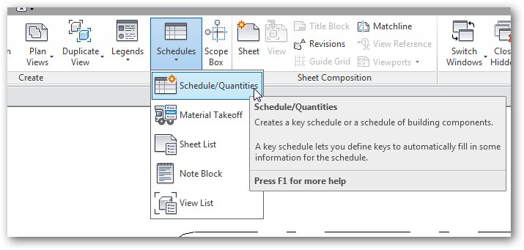
Figure 1

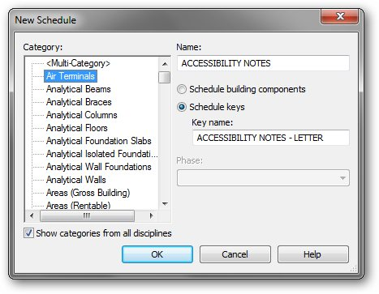
Figure 2
Name your schedule (here I’m creating Accessibility notes), as well as the Key Name field (which will become the column for the letter or number of each of your notes). Here, I’m using letters for my Accessibility notes, and so will name that column Accessibility Notes – Letter.
In the Fields tab, depending on what category you’ve chosen for your schedule (in my case Air Terminals) you might or might not have available fields. If you have Comments available, you can add that as your description column for your notes. If not, simply create a new parameter (Figure 3). I’ve called this Accessibility Notes – Description, of type Text. Note that you might create several of these schedules, all with parameters of ‘letter’ and ‘description’, hence it’s good to actually name them as descriptively as possible (i.e., General Notes-Letter and General Notes – description).
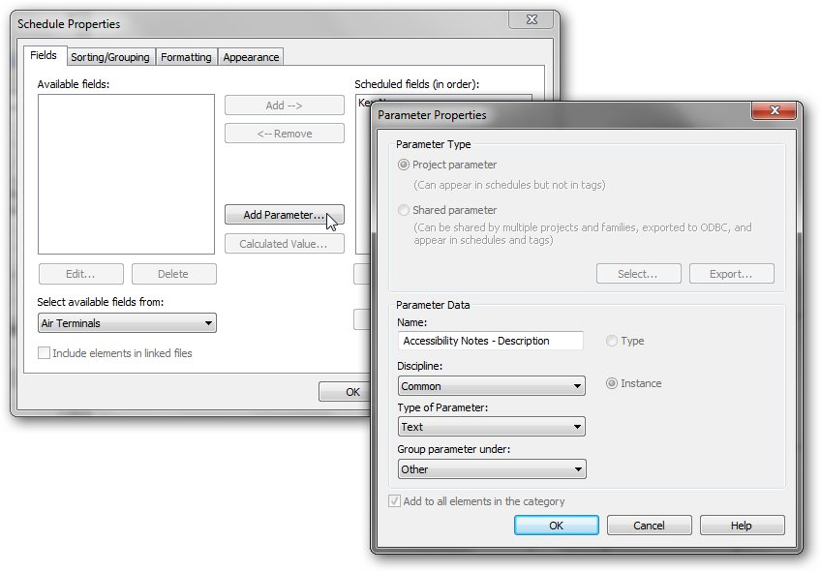
Figure 3
Under the Sorting/Grouping, make sure you pick to sort by Key Name (see Figure 4).
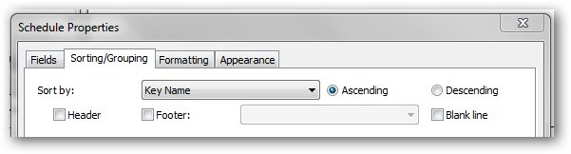
Figure 4
All that’s left is cosmetics. Under Appearance, make sure you uncheck Grid lines, Outline, and Show Headers, leaving only the title of your schedule (if needed). See Figure 5.
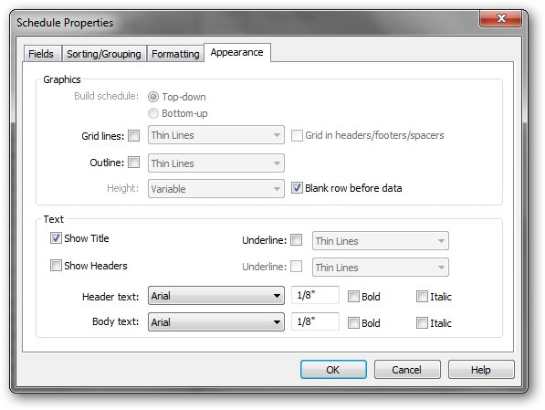
Figure 5
Once done, click OK to see your schedule and start adding rows to it. You can right-click and choose New Row (Figure 6) or select New Row from the ribbon menu.
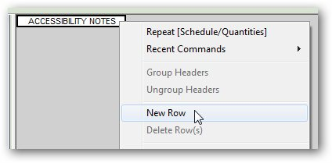
Figure 6
Simply copy/paste your text on each row (a tedious process, but it’s worth it) and you’ll have your completed multi-column notes schedule whose controls you can manipulate to your liking (see Figure 7).
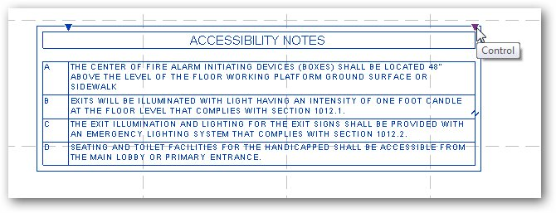
Figure 7
One additional tip: Sometimes, we have a collection of notes, some that are relevant to a certain set/kind of drawing while others are not, but are nevertheless grouped together. In this case, you might find it useful to create another column, named ‘Designer Notes’ for instance, where next to each ‘official’ note you can put a comment on where and how it should be used. Naturally, you would have to make the field Hidden when done, or delete that parameter altogether.
This workaround, although not ideal, is the optimum way to deal with multi-column notes. It’s suitable for all kinds of simple text schedules, such as Abbreviations and General Notes.

